# **How to use the genU LMS**

## What?

### What is the LMS?

LMS means: Learning Management System

### What do you need?

A computer, laptop or a tablet.

## Why?

### Why do you need the LMS?

So you can learn from home.

## How?

### How does it work?

Select your course and learn at home. 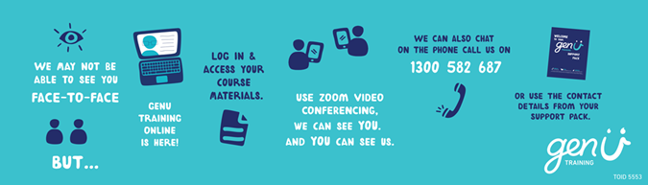

Contents

How to use the genU LMS 1

What? 1

What is the LMS? 1

What do you need? 1

Why? 1

Why do you need the LMS? 1

How? 1

How does it work? 1

Login 4

Feature Panel 5

Home page 7

Course Information 8

My Dashboard 10

Calendar 12

My Certificates 13

# How to use LMS on your device

You will get an email from genU Training about the LMS

The email contains instructions on how to log into the LMS for the first time.

1. The email will have a link to genU Training Online
2. Select the link <https://www.genutrainingonline.org.au/>
3. This will take you to genU Training Online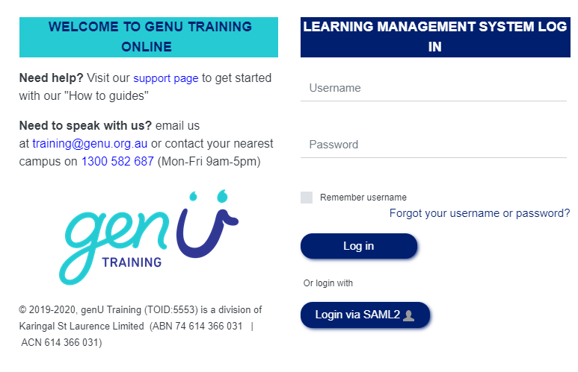

### Login

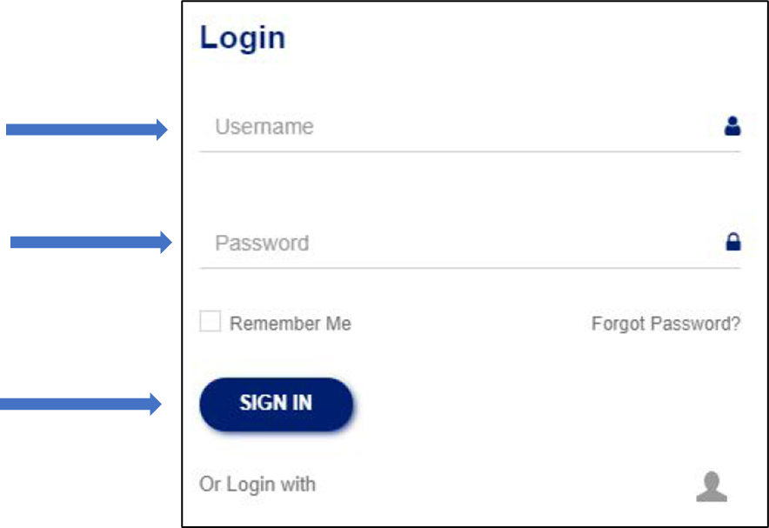

1. Type your username

Your username will be in your email

1. Type your password

Your password will have been set by you the first time you logged into the LMS. (Please refer to instructions on “How to log in for the first time”)

1. Select **Sign in**

### Feature Panel

Once you have logged into the LMS you will notice there is a side feature panel that can be opened and closed. The side Feature Panel contains blocks with varying information. For example, the **Latest Announcement** block has important genU Training Announcements.

Please note the Feature Panel is only available when accessing the LMS on a desk top computer or laptop. You will not be able to access the Feature Panel on mobile or tablet.

#### Open the Feature Panel

Select the Open Feature  Panel Icon.  icon to open the Feature Panel.

This will expand the Feature panel and will display available blocks.

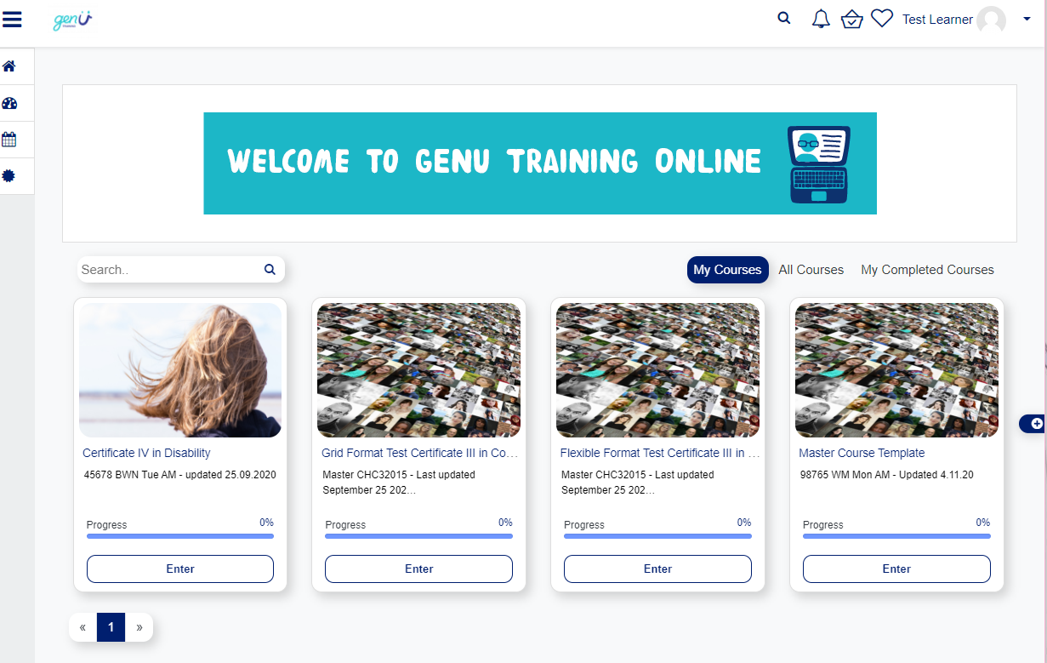

#### Close the Feature Panel

Select the Close Feature Panel icon to close the Feature Panel

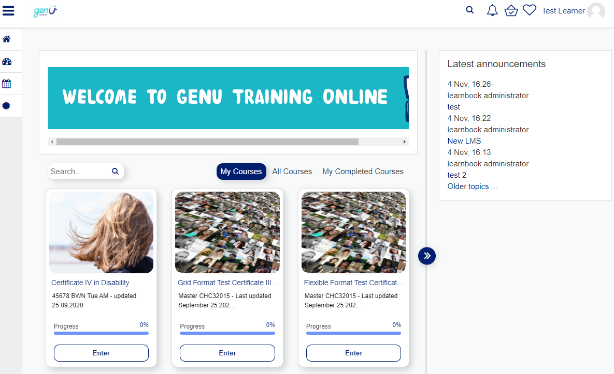

## Home page

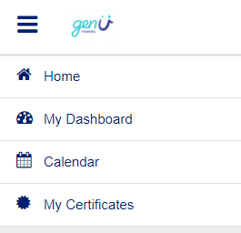

1. Select “Home”
2. Select “My Courses”
3. You can see the courses you are enrolled inScreen shot of the tab containing My courses, All courses and My Completed Courses headings. The My courses heading is highlighted.
4. Select “Enter”

Enter course button

### Course Information

Select the unit you are working on.

For example, CHCDIV001 Work with diverse people.

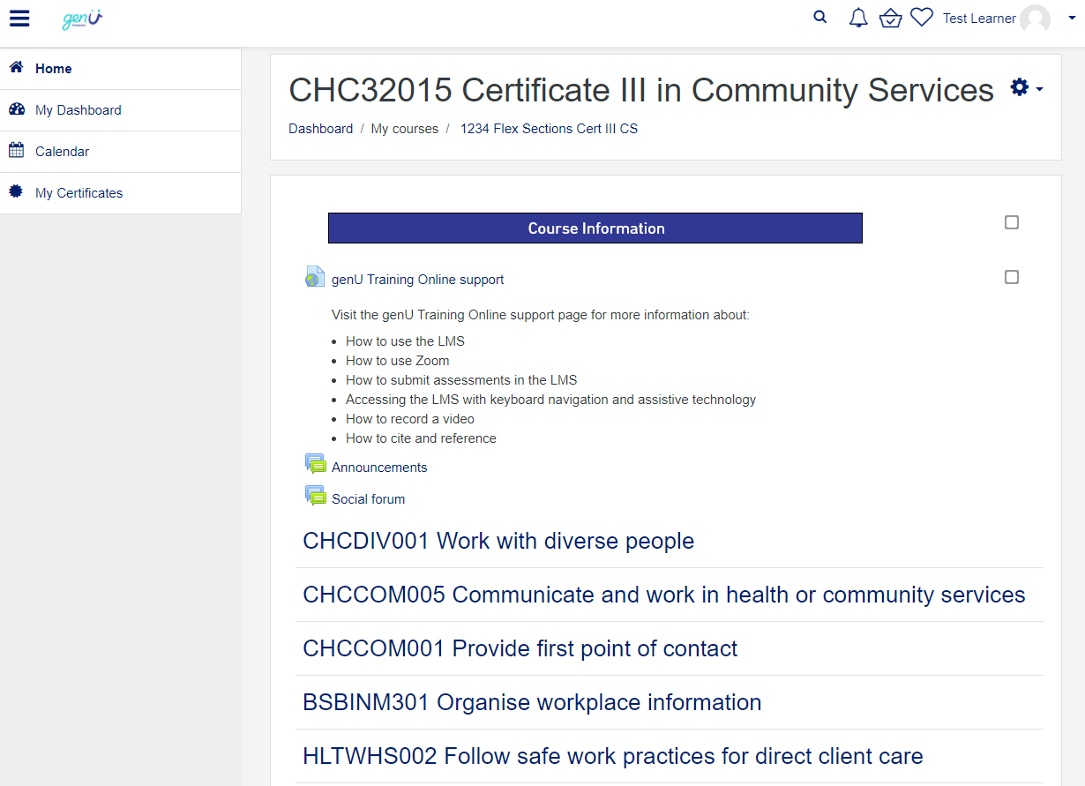

Every unit has:

* Learning Resources
* Social Forum
* Learner Assessments

#### How do I download files to my own computer?

1. For best results use Google Chrome as your internet browser
2. Select the file you want to download
3. When the file opens right click (or Ctrl S) to save as
4. Save the file

#### Learning Resources

Learning resources for each unit may include: Learner workbook, PowerPoint presentation, eLearning, video or website links, Word documents or PDF documents.

#### Discussion forum

This is a public class forum.

That means other learners, your Trainer and the Coordinator can read what you write.

* You can ask questions to your Trainer
* You can ask questions to other Learners in your class

#### Learner Assessments

You can print out your assessments so you can complete your work in writing.

Hand in your assessments on (or before) the due date.

#### How to hand in assessments

Sign and date every Assessment Task.

Choose 1 of these options:

1. Hand in your Assessment at the RTO
2. Scan your Assessment and send to your Trainer, as an attachment in an email
3. Post a printed Assessment to the RTO via mail
4. Submit your assessment in the LMS.

Refer to the document **Submit your assessment in the LMS** for details.

**Please note:** Some courses now have assessments in fillable PDF and Word. These assessments may be submitted online without printing first.

### My Dashboard



* You can see all the courses you are enrolled in
* You can see your grades
* You can see how much you have completed

**Example dashboard**

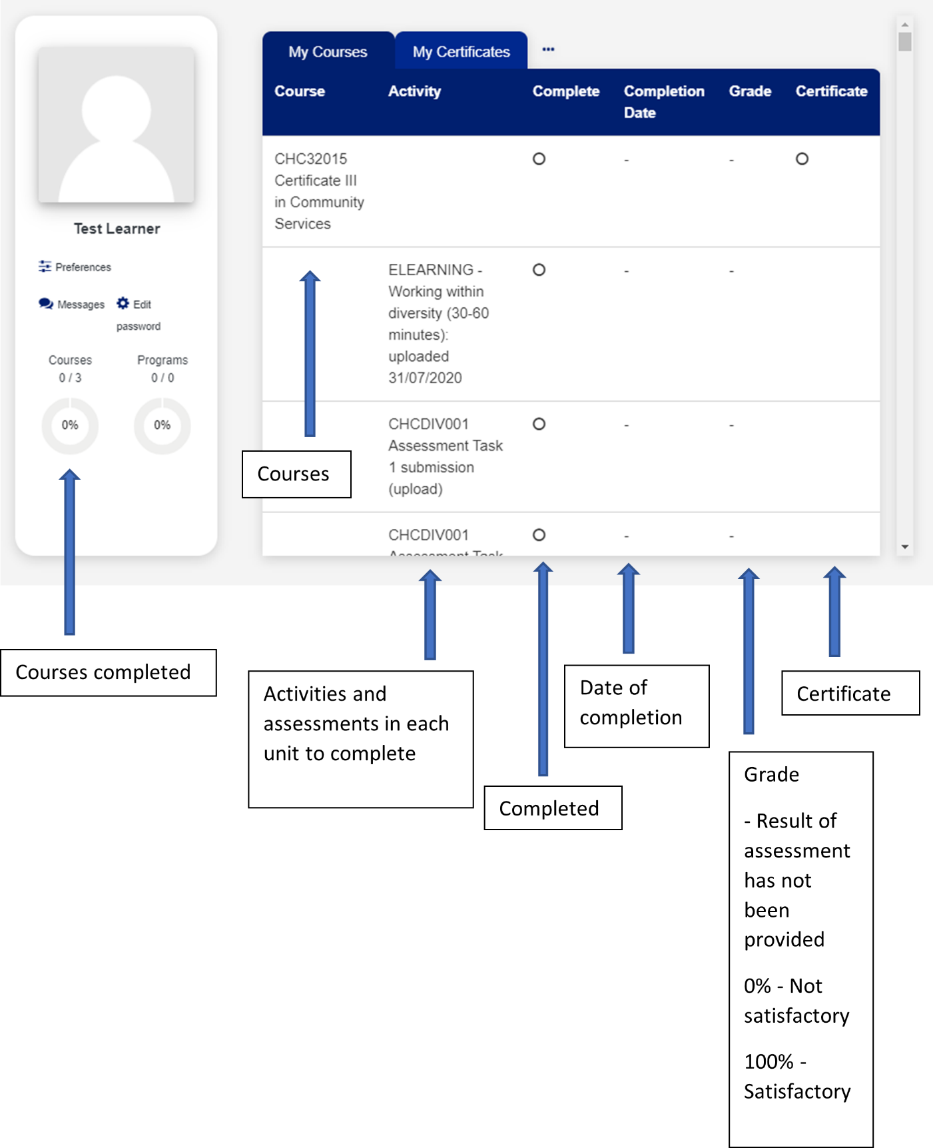

### Calendar

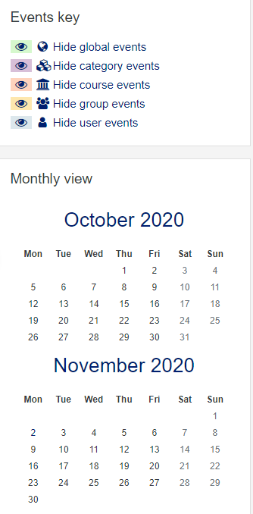

* You can see important dates and events
* You can add a reminder

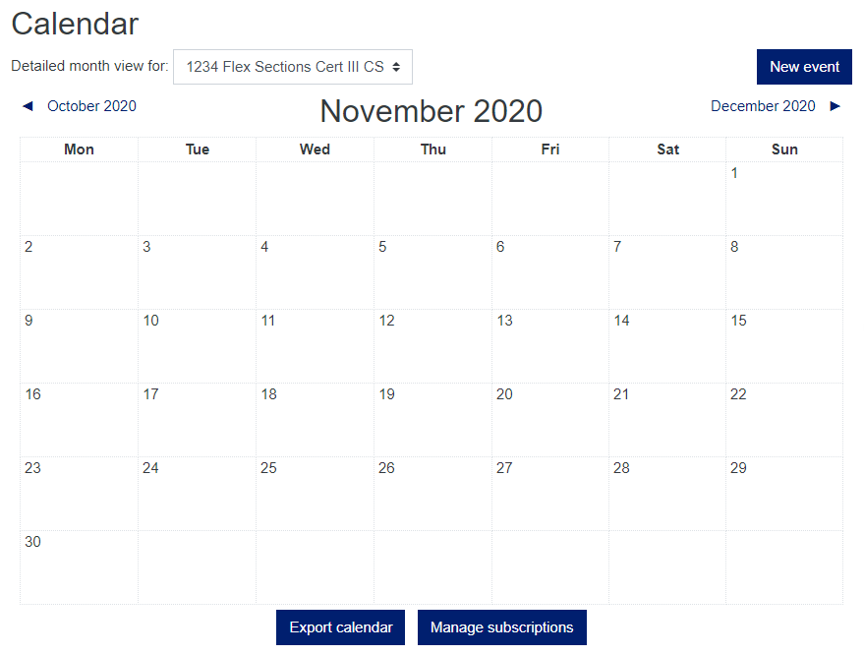

### My Certificates



* You can see all of your Certificates