How to use Zoom

Why?

Why do you need Zoom?
So you can talk to your Trainer and / or classmates.

What?

What do you need?
A device like a computer, laptop, tablet or mobile phone.

How?

How does it work?
You can have a 40 minute conversation with someone on your device. You can see and hear each other on your device screens.

How to join a Zoom meeting

On a computer
- Open your email
- Open your Zoom invitation
- Click on the Zoom link
- The link will look like this: https://genu.zoom.us/j/403782124

On a Mobile device
Download the Zoom app on your phone or tablet

Instructions for an IOS device
(Apple iPhone or iPad)
- Go to “Apple Store” on your device
- Type in Zoom
- Select “get”
- Select “open”

Instructions for an Android device
(Android smartphone or tablet)
- Go to “Google Play” on your device
- Type in Zoom
- Select “install”
- Select “open”

Sound (audio)
- Select “Join Audio” to hear sound
- Select “Automatically join audio by computer when joining a meeting”
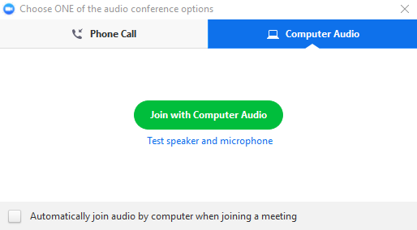
- Select “Join Audio” again to mute the sound
If there is a red line, the sound is off.

Screen (video)
- Select “Start Video” so others can see you.
This will only work if you have a camera.
If there is a red line, the camera is off.
- Select “Stop Video” to stop others from seeing you.

Chat
- Select “Chat”
- Type your message in the “To” section
Screenshot example
Enlarged screenshot of Chat box
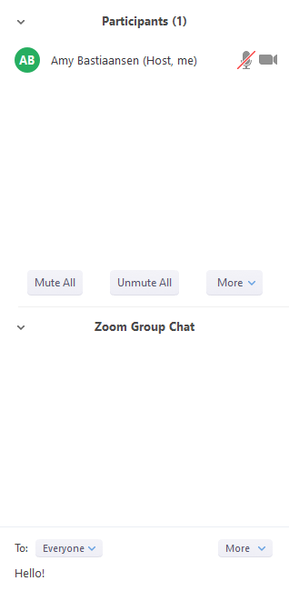

Summary
You can join Zoom via a link in your email invitation.
If there is a red line across:
The audio and the video are off.
If there is no red line:
The audio and the video are on.

