How to submit assessments in the genU LMS

What?

What is the LMS?
LMS means: Learning Management System

What is submit?
Submit means handing in.

What is assessment?
The tasks you need to complete for your genU course.

What do you need?
A computer, laptop or tablet and your assessments from the LMS.
If you complete assessments in fillable PDF format you will also need to use Adobe Acrobat Reader. Download the latest version of Adobe Acrobat Reader here.

Why?

Why are assessments in the LMS?
So you can do assessments at home

How?

How does it work?
Complete your assessments and hand them in from home.

Index
How to submit assessments in the genU LMS 1
What? 1
What is the LMS? 1
What is submit? 1
What is assessment? 1
What do you need? 1
Why? 1
Why are assessments in the LMS? 1
How? 1
How does it work? 1
Index 2
Name your file 3
OPTION 1: Assessment tools (all assessments for the unit in one document) 3
OPTION 2: Individual assessments 3
Upload your assessment 4
Step 1 – find the unit 4
Step 2 – find the upload link 5
Step 3 – select the link 5
Step 4 – add submission 6
Step 5 – add your file 6
Step 6 – save 7
Step 7 – want to add more? 7
Step 8 – submit 9
Step 9 – is it your work? 9
Step 10 – confirmation 9
Receiving feedback 11

Before you begin
If you choose to submit your assessments in fillable PDF format, download and use Adobe Acrobat Reader. Using software other than Adobe to complete fillable PDF assessments may cause reading issues with your work after it is submitted.

Name your file
If all your assessments for the unit are in one document choose OPTION 1.

OPTION 1: Assessment tools (all assessments for the unit in one document)
Save your assessment tools file as:
Your Name-UNIT CODE-Assessment ALL
For example:
Lucy Learner-CHCDIV001-ALL
If you have completed assessments one at a time in separate documents, choose OPTION 2.

OPTION 2: Individual assessments
Save your individual assessment file as:
Your Name-UNIT CODE-A<assessment task number>
For example:
Lucy Learner-CHCDIV001-A1

Upload your assessment

Step 1 – find the unit
Go to the unit of competency in the LMS
Example: CHCCCS025 Support relationship with carer and families
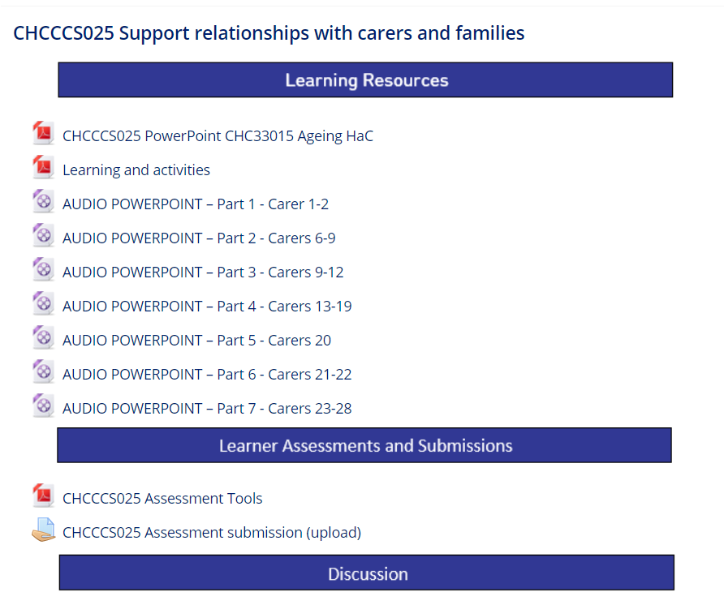

Step 2 – find the upload/submission link
Go to Learner Assessment and Submissions and find the Assessment submission (upload) link.
Example 1

Example 2
Select “My assessments”
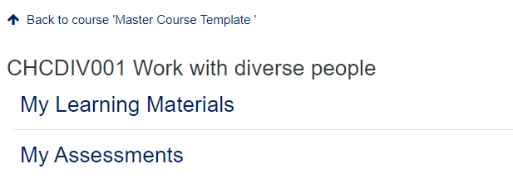
The submission links are listed under the heading “Submit my assessment”
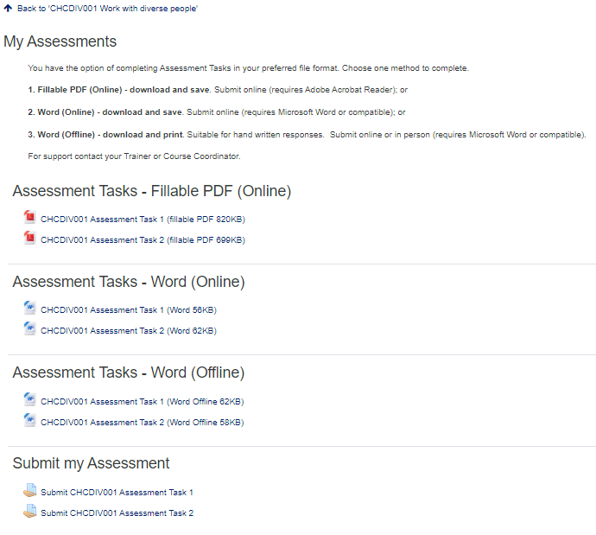

Step 3 – select the link
Example 1 - Select the Assessment submission (upload) link.
Example 2 – Select Submit link
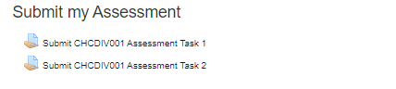

Step 4 – add submission
Select Add submission
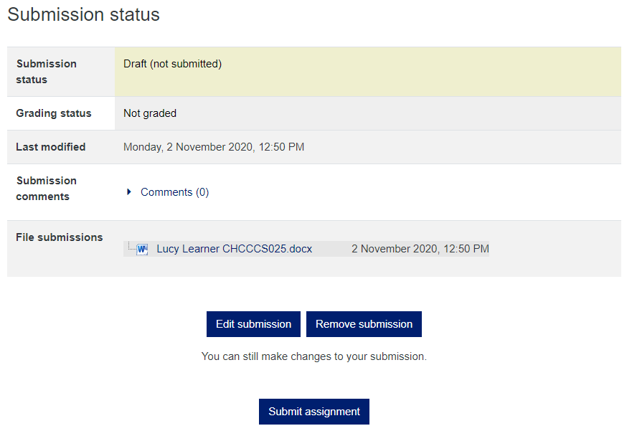

Step 5 – add your file
Drag and drop your file (or select the Add file option)
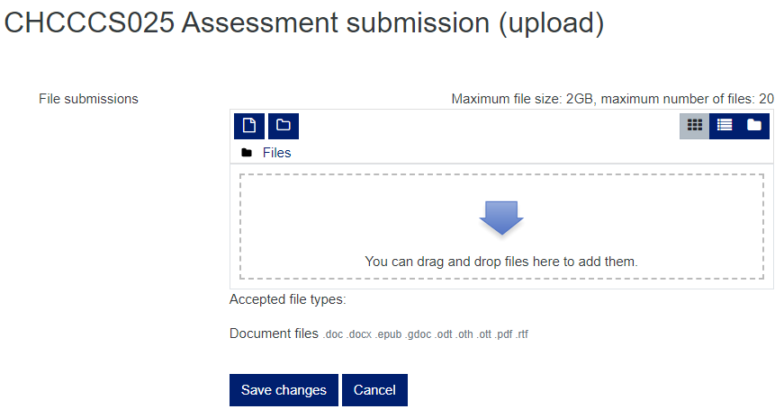
Add file

How many files can I upload?
Up to 20

How big can the files be?
Each file must be less than 4GB

What type of files are OK?
Most file types are accepted including:
Microsoft word (.doc, .docx)
Adobe Portable document files (.pdf)
Google docs (.gdoc)
Rich Text documents (.RTF)
e-book (.epub)
Open office documents (odt .oth .ott)

Step 6 – save
Select Save changes
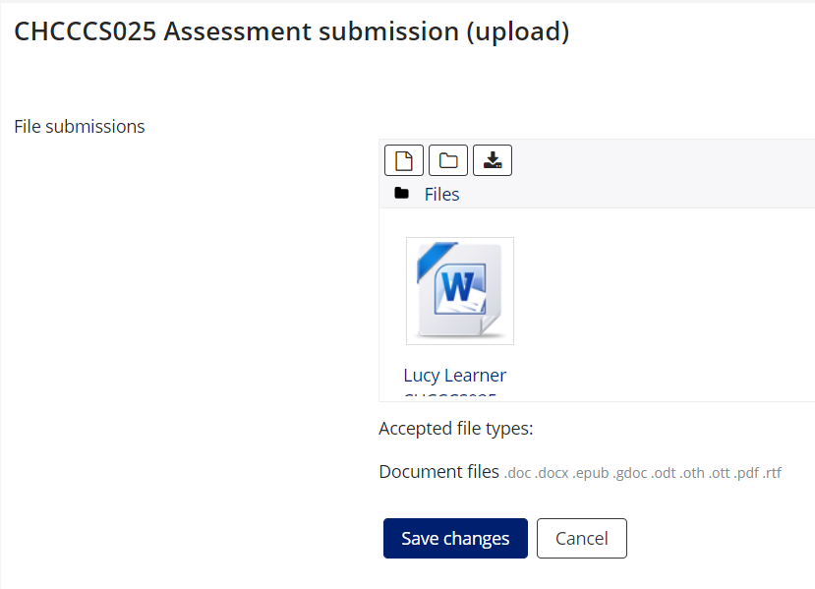

Step 7 – want to add more?
To add more assessment files, select “Edit submission” and repeat Steps 5 and 6.
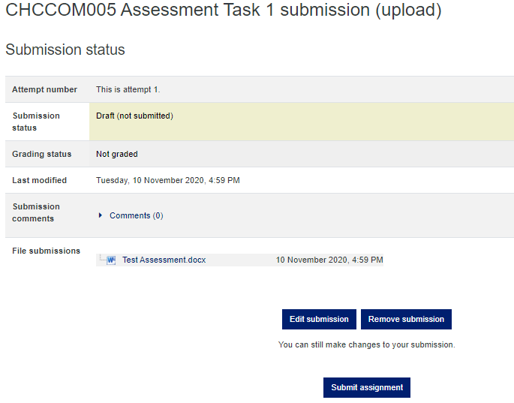

Step 8 – submit
Select Submit assignment when you are finished.
No more changes can be made after this.

Step 9 – is it your work?
If the work you submitted is your own work check the Learner declaration box and select Continue.
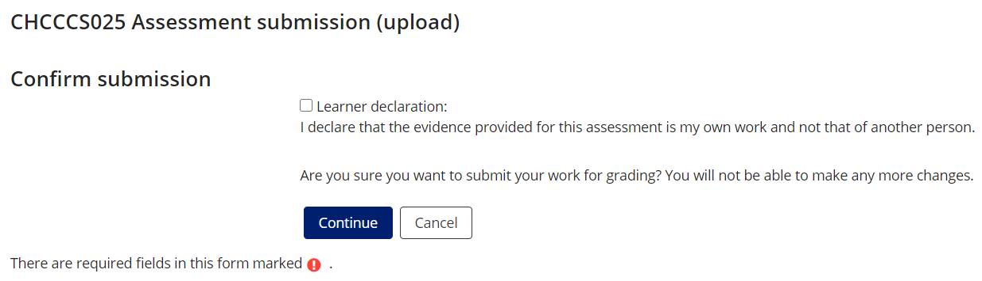

Step 10 – confirmation
The submission status for your upload will have changed to Submitted for grading.
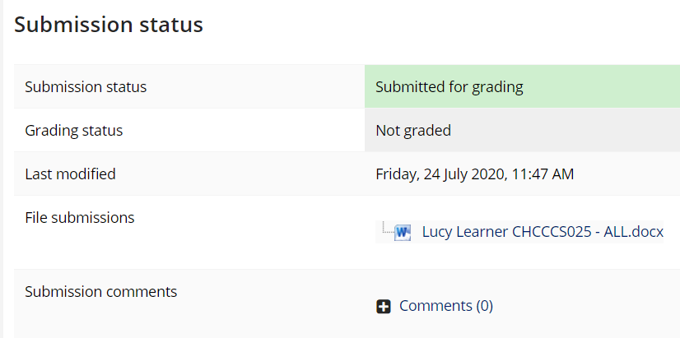

What happens next?
You (and your Course Trainer) will receive an email confirming your assessment submission.

Receiving feedback
If your trainer submits feedback in the LMS you will receive an email.
Example for CHCDIV001
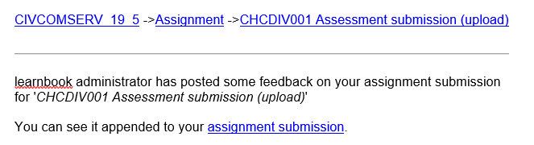
- Select assignment submission
- Go to Feedback (this will be the last item)
- Feedback comments and/or Feedback files are here.

You can also access feedback (if your trainer has provided) by logging into the LMS and selecting “My dashboard” from the home page.
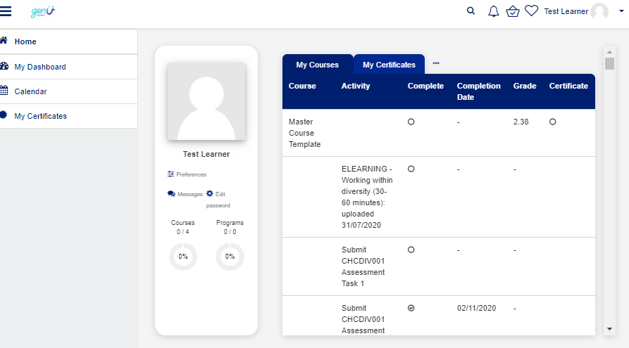
Select the unit in the My courses Tab that you wish to view feedback for. If you have submitted an assessment through LMS the completion date is the date you submitted the assessment.
