# How to record a video

## Instructions

Prior to recording your video ensure your device has:

* plenty of storage space
* sufficient battery

### Recording a video on a iPhone

#### Step 1

Go to ‘camera’ on your device

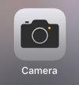

#### Step 2

Select the ‘video’ function



#### Step 3

Select the red record button to start recording



#### Step 4

Select the red record button to stop recording.

#### Step 5

Select the camera roll. The video will open.



#### Step 6

Select the ‘share’ icon.



#### Step 7

The ‘share’ icon will lead you to this screen. Select the ‘mail’ icon.

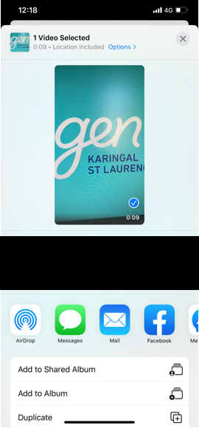

#### Step 8

The ‘mail’ icon will lead you to this screen. Send the video to your personal email address.

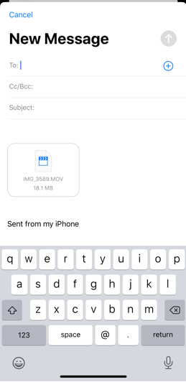

#### Step 9

Open the email on your personal computer.

#### Step 10

Save the video attachment to your personal computer.

#### Step 11

For instruction regarding the submission of assessments refer to the document **How to submit assessments in the LMS.**

### Recording a video on an Android

#### Step 1

Go to ‘camera’ on your device

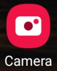

#### Step 2

Select the ‘video’ function

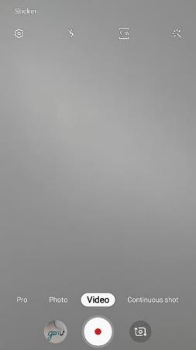

#### Step 3

Select the record button (red dot) to start recording



#### Step 4

Select the record button (red dot) to stop recording.

#### Step 5

Select the camera roll. The video will open.



#### Step 6

Select the ‘share’ icon.



#### Step 7

The ‘share’ icon will lead you to this screen. Select the ‘mail’ icon.

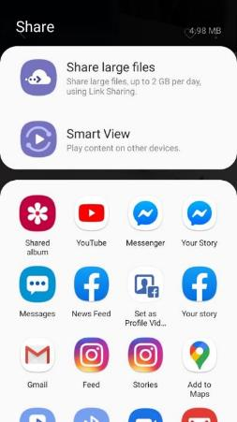

#### Step 8

The ‘mail’ icon will lead you to this screen. Send the video to your personal email address.

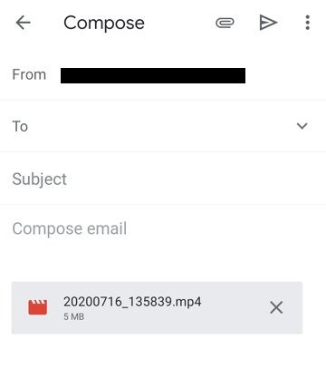

#### Step 9

Open the email on your personal computer.

#### Step 10

Save the video attachment to your personal computer.

#### Step 11

For instruction regarding the submission of assessments refer to the document **How to submit assessments in the LMS.**

### Recording a video using a webcam

#### Instructions

Before starting your video, do a test video of yourself speaking and play it back. Did you hear yourself clearly? If the answer is yes, go ahead and make your video. If you didn’t hear yourself clearly, you will need to place the microphone closer so that it picks up your voice. Once this is done, record your video

Prior to recording your video ensure your device has:

* plenty of storage space
* sufficient battery

##### Step 1

Go to ‘camera’ on your device

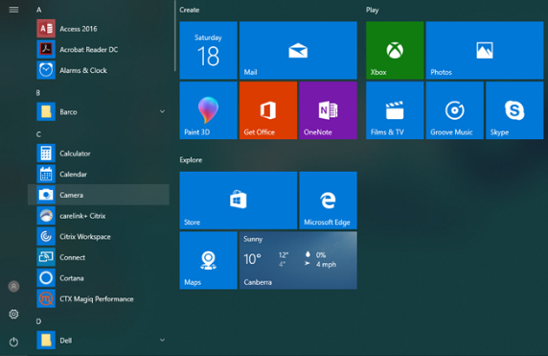

##### Step 2

Select the ‘video’ function

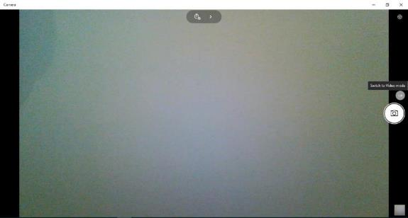

##### Step 3

Select the ‘video’ icon to start recording

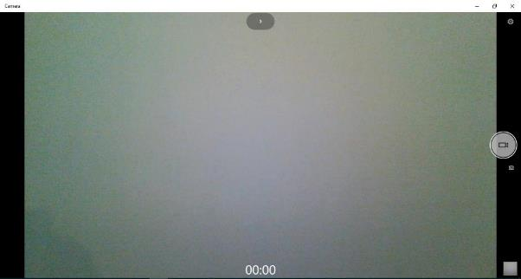

##### Step 4

Select to stop recording.

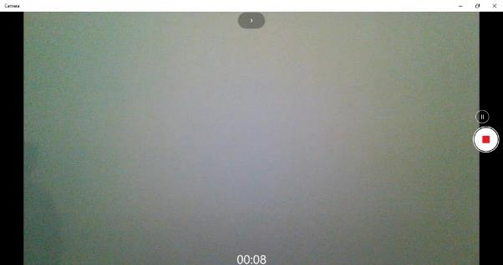

##### Step 5

Select the camera roll. The video will open.

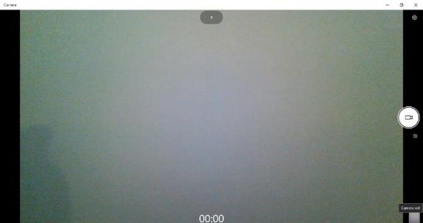

##### Step 6

Right click on the video and select ‘save as’ to save the video file to your personal computer.

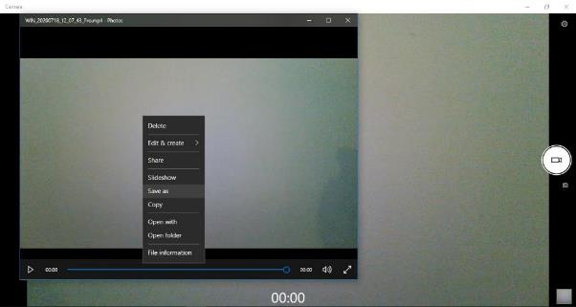

or

Select ‘save as’ from the ‘see more’ drop down menu to save the video file to your personal computer.

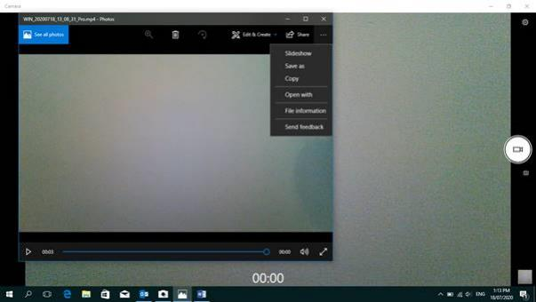

##### Step 7

For information about submitting assessments refer to the document **How to submit assessments in the LMS.**