Applying for an extension on your assessment

Step 1
Log into the genU Training Online LMS.

Step 2
Navigate to your course and the unit that you wish to apply an extension.

Step 3
Download and fill in the “Application form for extension” (PDF and Word available)
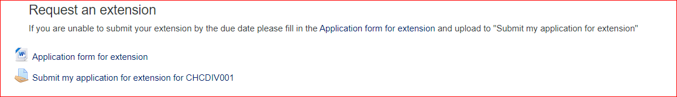

Step 4
Save a copy of your application form.

Step 5
Select “Submit my application for extension for (Unit)”

Step 6
Select “Add submission”
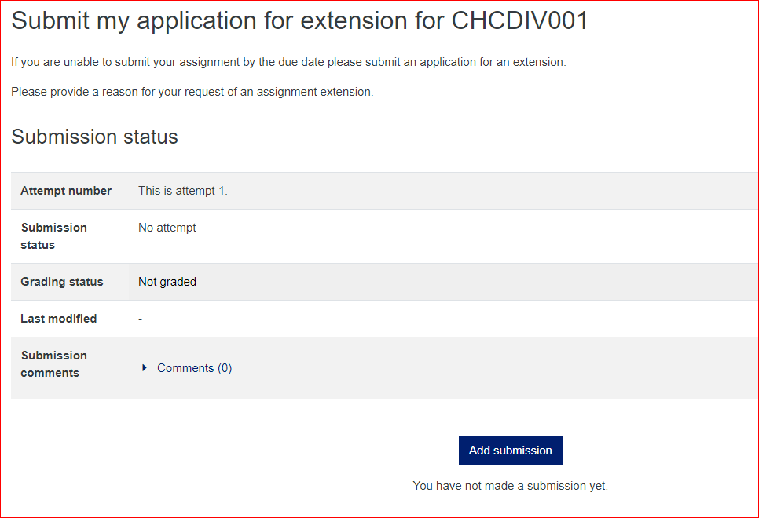

Step 7
Upload completed application for extension form
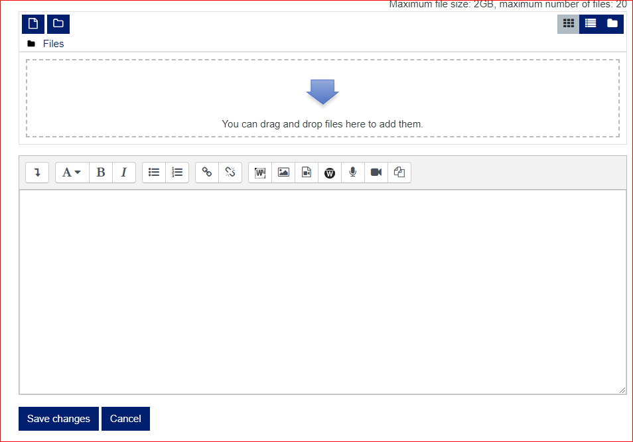

Step 8
Select “Submit Assignment”
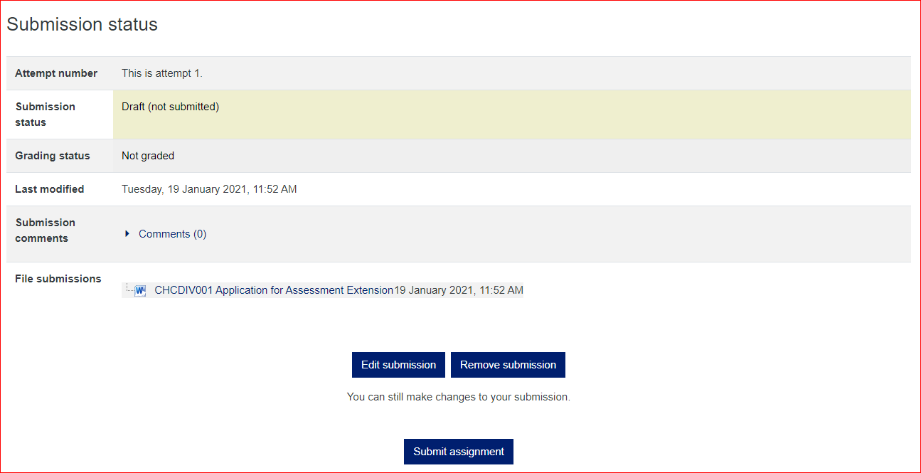
Your application for an extension has now been submitted.
Your coordinator will review your application and you will receive a notification on the LMS to inform you of your application result.

