FREE Adobe Acrobat Reader DC
To complete genU Training fillable PDF Assessments use:
Adobe Acrobat Reader DC

Download Adobe Acrobat Reader DC for PC:
https://helpx.adobe.com/acrobat/kb/install-reader-dc-windows.html
Download Adobe Acrobat Reader DC for Mac:
https://helpx.adobe.com/acrobat/kb/install-reader-dc-mac-os.html

Setting Adobe Acrobat Reader DC as default program to open PDF documents on PC.
https://helpx.adobe.com/acrobat/kb/not-default-pdf-owner-windows10.html

FAQ
Do I have to use Adobe Acrobat Reader DC? I have other programs on my computer and can open the fillable PDF.
Using Adobe Acrobat Reader DC ensures that each time you complete a fillable Assessment task will avoid any inconsistencies that may arise from using other programs.
Your computer may have default programs that will automatically open a PDF document. Using other programs may prevent your trainer from being able to see the responses to your assessment questions.
Can I copy and paste text into the fillable PDF assessments?
The assessment tools requires you to enter your responses in your own words. We do not recommend for you to copy and paste content from other sources into the text box as this may cause the document not to display the responses to your trainer. If for whatever reason you are required to copy large volume of text we recommend you use the Word version of the Assessment Tool to complete your assessment.
How can I tell if I am using Adobe Acrobat Reader DC?
Adobe Acrobat Reader DC should look like the below image when you open your document. The top left hand corner after the file name should have “Adobe Acrobat Reader DC”
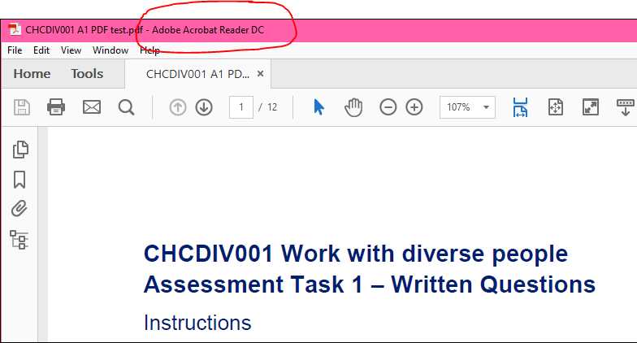
Another way to confirm that you have opened your document with Adobe Reader DC is to right click the file – Select “Open with” – Select “Adobe Acrobat Reader DC”
If you do not see an option to open with Adobe Acrobat Reader DC it means you do not have the program installed and will need to download it.

