Accessing the genU LMS
with keyboard navigation and assistive technology
genU online training courses are keyboard navigation accessible and have been tested using both Apple and JAWs screen readers.

What if I have an issue?
Sometimes we get things wrong. Please let us know straight away if you experience an accessibility issue and we will fix it. Visit our support page, or contact us on 1300 582 687, or email training@genu.org.au

Logging in for the first time

First time learner
The first time you log into genU online training with your user name and password you will be directed to a Site Security acknowledgement. If you accept the terms of use please select the Accept button.

SCREEN READER TIP: Maximise the size of your browser window
If your browser window is not fully maximised performance issues will occur when you attempt to load a new course or navigate away from the menu.
In JAWs you can maximise the browser window by selecting both ALT and SPACE BAR, then press x or select maximize.

SCREEN READER TIP: If you experience issues loading courses
Poor internet performance can result in difficulty loading courses. Close your browser window and reload JAWs if the online training environment or the course you are navigating fails.

Web browser performance
The following web browsers consistently perform well for all users:
- Google Chrome
Performance issues may occur from time to time with:
- Internet Explorer
- Microsoft Edge
- Safari
- Firefox

The Home page
The Home page will open when you log in. From here you can access the side tab menu which contains options for Home, My Dashboard, Calendar, My Certificate and My Teams. The Home page itself contains options for My Courses, Catalogue, Completed, Search and different viewing layouts. Navigate past all of these to the Enter Course button for the course you are enrolled in.

SCREEN READER TIP: Starting your new course
To commence the course you are enrolled in navigate to the course heading name by pressing h. Underneath you will find the course link. Press b to navigate past course administrative details and select the ENTER button.

Accessing PDF documents
Presentation slides, assessments and some other learner resources are provided using portable document format (PDF).
PDFs will not perform successfully in some browsers. We recommend downloading the latest free version of Adobe Acrobat Reader.
If you complete assessments in fillable PDF format Adobe Acrobat Reader is the only successful option to use to ensure readability by your assessor.

Assessment signatures in PDF
Assessor Checklists and some observation documents provided in PDF format contain fields for signatures to be added. Due to software limitations in Adobe PDF, signatures that are added digitally (or manually) will identify as blank by screen readers.

Accessing eLearning
genU uses Articulate Storyline 360 software for our eLearning.
There are minimum system requirements for you to be able to view and access genU eLearning. The latest version of Google Chrome will work well for Windows, Mac and Mobile users. Details about other system requirements are available from the Articulate website:
Required browser settings for viewing Articulate eLearnings
Keyboard and screen reader navigation works slightly differently in eLearning courses. Some information about Menus navigation and reading content is provided. If you would like more detailed information about viewing accessible content, refer to the Articulate website:
Accessibility in published courses

Loading a new course
It often takes a few seconds to load a new course. If you attempt to navigate before the course has completely loaded you are likely to experience navigation issues that will result in having to launch the course again.

SCREEN READER TIP: Wait 30 seconds before navigating
When you load a new course wait 30 seconds before navigating. If a course has not fully loaded in JAWs tab to the launch button, then select ENTER.

Menu
The eLearning navigation menu functions as a tree control for keyboard users, including collapsing and expanding sections.
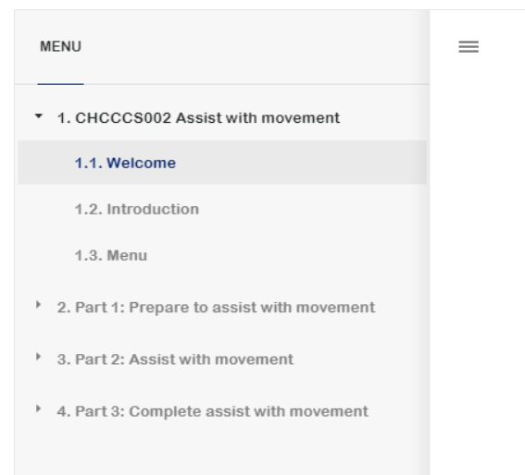
Screen readers will announce the current level in the hierarchy, the learner's position in the menu, and the active item. This may result in some repetition.
For example, for the Welcome slide you will hear:
- Slide colon Welcome (announcing hierarchy level)
- Slide colon Welcome (announcing position in menu)
- Slide colon Welcome (announcing active item)

Keyboard shortcuts for the sidebar menu:
Keyboard shortcut key | Shortcut action
Enter | Activates the selected item
Home/End | Jumps to first or last item
Arrows | Moves through items

Reading content
Auto-read is switched off at the commencement of every slide and after an object is activated (buttons/markers/links).
Use up and down arrows to move through items on the slide. If you navigate item by item some items will read as "blank". If you commence auto-read after the slide title is announced or after buttons/markers/links are activated no "blanks" will be read.

Keyboard shortcuts for reading content:
Keyboard shortcut key | Shortcut action
Insert + down arrow | Auto-read content for assistive technology users
ESC | Stop auto-read for assistive technology users
Up and down arrows | Moves through and reads each item one at a time
Tab (and shift Tab) | Moves to interactive objects (buttons, markers, links)
Spacebar or Enter | Activates objects (buttons, markers, links).
CTRL + W | Return to the eLearning after opening a link or new window.
Z | Toggle zoom

NOTE: Opening links in Chrome browser
Chrome browser may unexpectedly open two browser windows when links are activated. This will not interfere with any other processes but both windows will need to be closed or minimised before commencing.

Exiting the eLearning
When you select ALT F4 or EXIT at the completion of a course, you will return to the genU course page. Proceed to the Log out button.

